CSA1708-ARTIFICIAL INTELLIGENCE
LAB EXPERIMENTS
Program 2 : Python Program to Solve 8-Queen Problem
Aim
To develop a Python program that solves the 8-Queen Problem using backtracking to place eight non-attacking queens on an 8×8 chessboard such that no two queens share the same row, column, or diagonal.
Algorithm
1. Initialize an 8×8 chessboard with all cells set to 0.
2. Start placing queens column by column beginning from the leftmost column (col = 0).
3. If all 8 queens are safely placed (col >= 8), the solution is found; print the chessboard layout.
4. For the current column, iterate through all rows from 0 to 7:
5. a. Check if the cell (row, col) is safe from attacks by previously placed queens (verify row to the left, upper-left diagonal, and lower-left diagonal).
6. b. If the position is safe, place the queen by setting board[row][col] = 1.
7. c. Recursively call the placement function for the next column (col + 1).
8. d. If placing the queen does not lead to a solution, backtrack by resetting board[row][col] = 0 and try the next row.
9. If all rows in the current column have been tried and no safe position is found, return False to trigger backtracking to the preceding column.
10. Display the final non-conflicting 8-Queen board configuration.

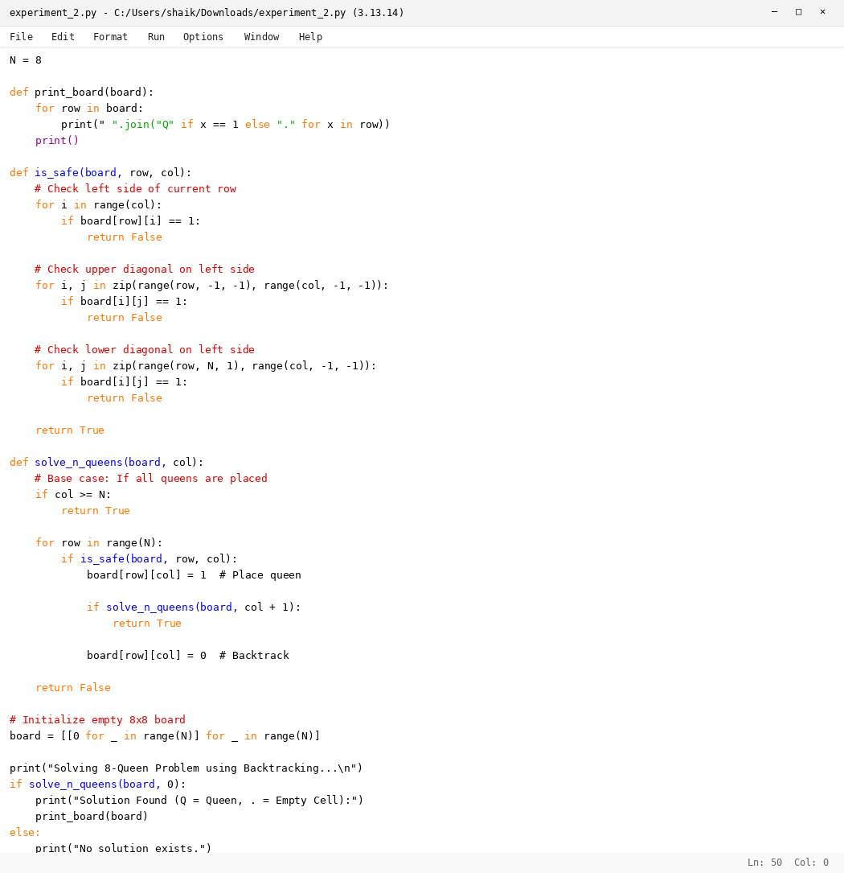

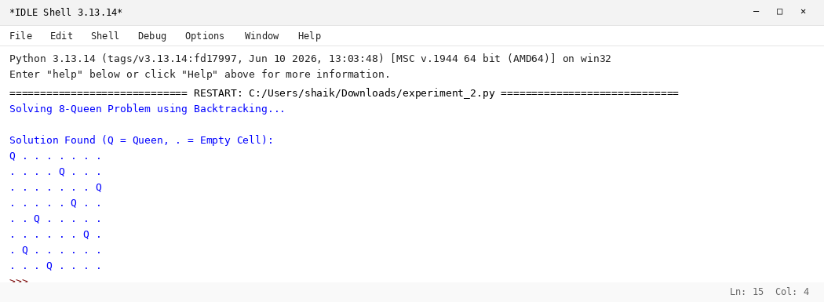

RESULT
Thus, the 8-Queen Problem was solved successfully using Python.

